UNIVERSITY HEALTH CENTRE AT QUEENS

Activity Data
01/04/2025 – 31/03/2026

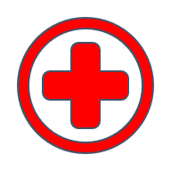 | 17,537  People had a face to face consultation
   | 8,722  People had a telephone consultation
 | 36  People had a home visit
 | 66,395  Administration encounters were completed by the Practice

